Software Requirements Specification

for

WebIMS: Intelligent Medical Software

**Version 1.0 approved**

**Prepared by**

**19ce016 Dhruvil Chaudhary, 19ce076 Nikita Mirchandani,19ce119 Hemit Rana**

**Meditab Software (India) Pvt**

**21/2/2023**

**Table of Contents**

**Table of Contents ii**

**Revision History ii**

**1. Introduction 1**

1.1 Purpose 1

1.2 Document Conventions 1

1.3 Intended Audience and Reading Suggestions 1

1.4 Project Scope 1

1.5 References 1

**2. Overall Description 3**

2.1 Product Perspective 3

2.2 Product Features 3

2.3 User Classes and Characteristics 3

2.4 Operating Environment 4

2.5 Design and Implementation Constraints 4

2.6 Assumptions and Dependencies 5

**3. System Features 6**

3.1 New Patient Creation 6

3.2 Patient Data Retrieval 6

3.3 Patient Data Updation 7

3.4 Patient Deletion 8

3.5 Patient Allergy Section 8

**4. External Interface Requirements 10**

4.1 User Interfaces 10

4.2 Software Interfaces 14

4.3 Communications Interfaces 14

**5. Other Nonfunctional Requirements 15**

5.1 Performance Requirements 15

5.3 Security Requirements 15

5.4 Software Quality Attributes 15

**6. Other Requirements 16**

**Appendix A: Glossary 17**

**Appendix B: Analysis Models 17**

**Appendix C: Issues List 19**

**Revision History**

| **Name** | **Date** | **Reason For Changes** | **Version** |
| --- | --- | --- | --- |
|  |  |  |  |
|  |  |  |  |

# Introduction

## Purpose

## The Purpose of Software Requirements Specification (SRS) is to provide a detailed description of the Medical Billing and Electronic Health Record management system. SRS will give a complete understanding of purpose and its functionality. This document helps developers to understand software correctly as well as it can be used as a software validation document for users.

## Document Conventions

## When writing the SRS document for the 8th Semester SPM the following terminologies are: To make the document more effective and readable we used Times New Roman font style and 11 font size and headings are bold.

## Intended Audience and Reading Suggestions

## This document is intended for developers who are developing for the IMS product.

## This SRS contains the details of the project, along with its features, a visual description and how it is organized. The sequence for reading the document, begins with the overview section and proceeds in the order of the documentation.

## Project Scope

## It may help for patients to book appointments, take insurance, and take medicine by order in this covid pandemic. It will help a patient to know the management of the past year perfectly and vividly. It helps in current work relative to Medical Software and Billing systems. It will also reduce the cost of collecting the management & collection procedure will go on smoothly. In this project our main aims are Business process automation, i.e we have tried to computerize various processes of Medical billing and insurance software.

## In this web application the patient has to fill the various forms & number of copies of the forms can be easily generated at a time. This application generates types of information that can be used for various purposes. And its easy to operate. The schedule of patient appointments is managed easily. Be expandable.

## Application also provides excel export of patient records and Billing records for clinics.

## Manually creating a Web Application and configuring a website on it is a very tedious job. Moreover sometimes we even need to maintain patient health data for which we require the setup of Angular which too is a tedious process to perform.

## This process is very time consuming as well as erroneous because as there is a human hand involved, there is even a scope of error for sure and it is difficult to maintain consistency.

## The .Net technology and node js will take care of this backend process and for data storage Postgres database will be used.

# Overall Description

## Product Perspective

## System analysis is a process of gathering and interpreting facts, diagnosing problems and the information about the Intelligent Medical System to recommend improvements on the system. It is a problem-solving activity that requires intensive communication between the system users and systems development process. The Billing process and insurance from the organization are traced to the different processes. The system analyst plays the role of the interrogator into the working of the current system. The conclusion is an understanding of how the system functions. This system is called the existing system. Now the existing system is subjected to close study and problem areas are identified. The solutions are given as proposals. The proposal is then weighed with the current system analytically and the best one is selected. The proposal is reviewed on user request and suitable changes are made. This is a loop that ends as soon as the user is satisfied with a tight proposal. System study is a problem solving activity that requires intensive communication between the system users and system developers.

## Product Features

## Provides the searching facilities based on various factors. Such as Patient, Medicine Company, Medicine Stock, Sells and Insurance Company.

## It also manages the supplier details online for Medicine stock details, sells details, and customers. Then manage the billing provider details, visit note status, appointment details of patient , room allocation to patient , patient case, patient family history, patient insurance claims, Patient prescription, patient receipts, etc.

## Shows the information and description of the patient, clinic.

## Integration of all records of sales.

## User Classes and Characteristics

## In healthcare the main stakeholders are Patients, Providers (professionals and institutions), Payors, and Policymakers ('The four Ps' in healthcare). Moreover, industry (e.g., medical device, pharmaceutical, biotechnology), regulators, research community, and media are also important.

## Operating Environment

## HARDWARE REQUIREMENT

## Processor: Intel(R) Core (TM) i5-9500 CPU @ 3.00GHz 3.00 GHz

## Computer Displays and Display Resolution, Multiple Users and Network Operation, Patient ID Card Scanning, Label Printers, Computers and

## Operating Systems: Windows, Linux

## RAM: 16 GB

## Hard Disk: 235 GB

## SOFTWARE REQUIREMENTS

## Operating System: Windows 11

## Language: Java 2 Runtime Environment

## Database: Postgres

## Web Server: Local

## Browser: Microsoft edge, chrome etc.

## .NET version: 6.0

## Design and Implementation Constraints

## Other few technical challenges that fail the implementation of Medical Billing and Electronic Health record management system, in the healthcare industry includes Networks and computers have different maintenance problems, lack of no standards for Data entry and data retrieval, difficulties in training users technically to use Medical Billing and Electronic Health record management system.

## The software currently will operate in English (US) and Spanish language only.

## Operating machines must have internet connectivity.

## Assumptions and Dependencies

# Lack of Long-Range Planning: Organizations are involved in achieving the objectives of temporary projects

# Organization Disruption: Projects compete for people and resources with functional departments.

# Another limitation of this application is shifting people from project to project may constrain the training and development of new employees by experienced employees and billing providers.

# Project may not be suitable for all tasks. It is not suitable for small organizations which lack resources.

# To run the project only specific version should be allowed

# System Features

## New patient creation

**3.1.1 Description and Priority**

* + This feature is for the user to register their details and has an ability to make changes if the entered details are invalid or incorrect. It’s a higher priority feature.
  + This feature will collect and manage information of patients like name, dob and other pharmacy details.
  + Priority of this feature is High.

**3.1.2 Stimulus/Response Sequences**

Stimulus: User enters the details and clicks on save.

Response: toast will be shown and the user data is created.

**3.1.3 Functional Requirements**

| Feature ID | Feature Name | Description |
| --- | --- | --- |
| FR-NPC-1 | Insert User data like name, dob and other demographics details, contact details etc. | The application shall allow user to insert their details and able to save it. |

## Patient data retrieval

**3.2.1 Description and Priority**

* + This feature is for the providers to get the patient data by using their id in url or searching their first name, last name, dob, sex.
  + This feature will collect and manage information of patients and show it in the fields of the patient demographics.
  + Priority of this feature is High.

**3.2.2 Stimulus/Response Sequences**

Stimulus: User enters the search key and presses enter.

Response: all the patient data is displayed according to the search key.

**3.2.3 Functional Requirements**

| Feature ID | Feature Name | Description |
| --- | --- | --- |
| FR-PDR-1 | Insert id for which patient data user wanted. | The application shall allow the user to insert a patient id and the user should get the patient details. |
| FR-PDR-2 | Insert first name, last name, sex or dob for which patient data user wanted. | The application shall allow the user to insert patient first name, last name, sex or dob and user should get the patient details. |

## Patient data updation

**3.3.1 Description and Priority**

* + This feature is for the providers to update the patient data by using their id in url or searching their first name, last name, dob, sex.
  + This feature will collect and manage information of patients and show it in the fields of the patient demographics and if any details are changed then user may cancel changes or save it to update successfully.
  + Priority of this feature is High.

**3.3.2 Stimulus/Response Sequences**

Stimulus: User enters the search key and presses enter then changes required details and press on save.

Response: all the patient updated data is saved successfully.

Stimulus: User presses on cancel changes.

Response: all the patient updated data is cleared successfully and previous data is displayed.

**3.3.3 Functional Requirements**

| Feature ID | Feature Name | Description |
| --- | --- | --- |
| FR-PDU-1 | enters the search key and presses enter then changes required details and press on save. | The application shall allow the user to update patient data and the user should get the patient details updated. |
| FR-PDU-2 | cancel changes. | The application shall allow user to cancel changes they have made. |

## Patient data deleting

**3.4.1 Description and Priority**

* + This feature is for the providers to delete the patient data by using their id.
  + This feature will delete information of patients.
  + Priority of this feature is High.

**3.4.2 Stimulus/Response Sequences**

Stimulus: User enters the patient id and presses enter.

Response: all the patient data is deleted according to the patient id.

**3.4.3 Functional Requirements**

| Feature ID | Feature Name | Description |
| --- | --- | --- |
| FR-PDD-1 | Insert id for which patient data user wanted to delete. | The application shall allow the user to input patient id and data should be deleted. |

## Patient allergy section

**3.5.1 Description and Priority**

* + This feature is for the providers to handle the patient allergy data through the changelog passed through the patient data form.
  + Changelog of patient allergy data: created, updated and deleted
  + This feature will manipulate information about patients' allergies.
  + Priority of this feature is High.

**3.5.2 Stimulus/Response Sequences**

Stimulus: User enters the patient allergy data then presses on save.

Response: all the patient allergy data is added according to the patient id into the patient allergy data.

Stimulus: User update the patient allergy data then presses on save.

Response: all the updated patient allergy data is updated according to the patient id into the patient allergy data.

Stimulus: User deletes the patient allergy data then presses on save.

Response: all the patient allergy data is deleted according to the deleted patient allergy record into the patient allergy data.

**3.5.3 Functional Requirements**

| Feature ID | Feature Name | Description |
| --- | --- | --- |
| FR-PAS-1 | Created patient allergy data | The application shall allow user to insert new patient allergy data. |
| FR-PAS-2 | Updated patient allergy data | The application shall allow user to update existing patient allergy data. |
| FR-PAS-3 | Deleted patient allergy data | The application shall allow user to delete existing patient allergy data. |

# External Interface Requirements

The basic GUI (Graphical User Interface) of the project is been mentioned below:

## User Interfaces

The interface Will be in the form of a web page.

**4.1.1 Home Page**

This is the home page of our website.

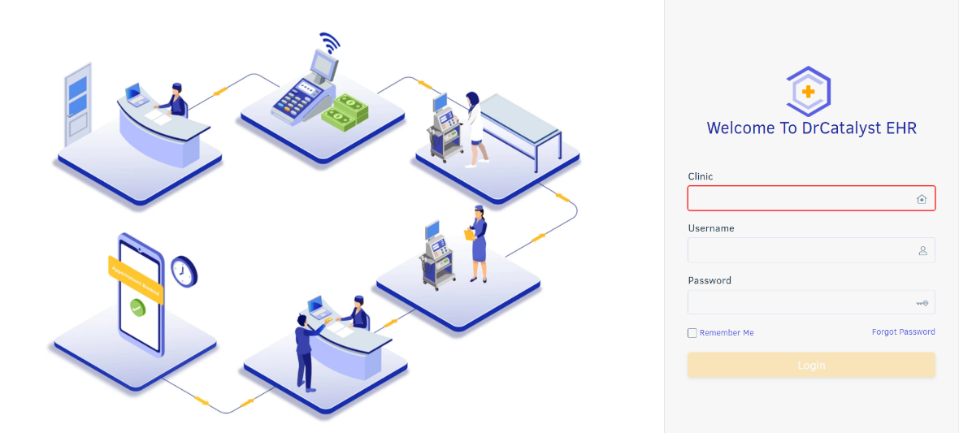

*Figure 4.1 Home Page*

**4.1.2 Patient demographics page**

In this page users add patient data and create new patients or update patient data and save them. On the left side there is a navigation sidebar from which the user can select the appropriate option.

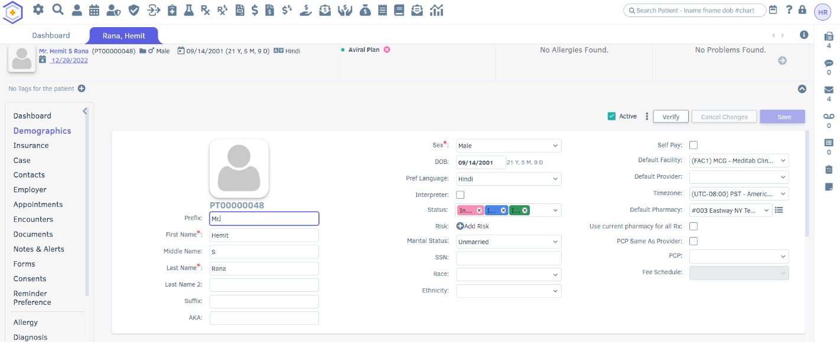

*Figure 4.2 Patient demographics page*

**4.1.3 patient demographics contact details section**

In this section users can add patient contact details like their address or phone numbers and also have the facilities of adding multiple addresses and contacts.

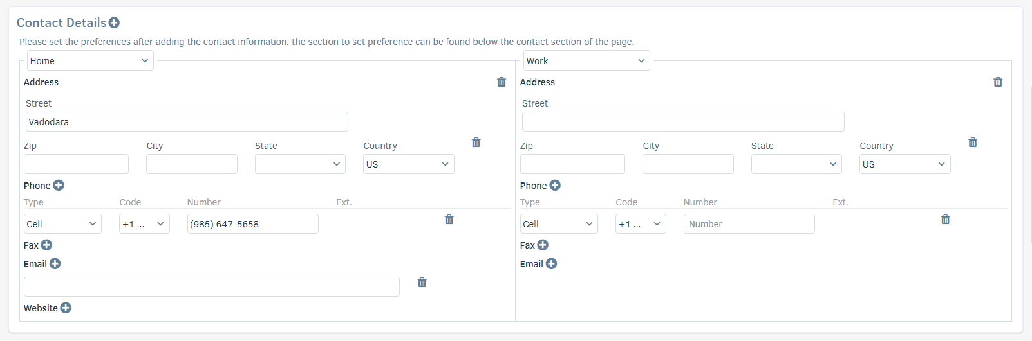

*Figure 4.3 Patient demographics contact details section*

**4.1.4 patient demographics contact preference details**

In this section user can select patients’ preferred addresses and contacts. All details will be automatically suggested by the saved contact details.

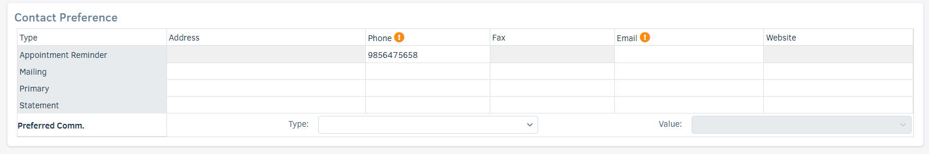

*Figure 4.4 Patient demographics contact preference details*

**4.1.5 patient other details**

In this section patients’ other details can be added by user like employment or first called date or relatives details etc.

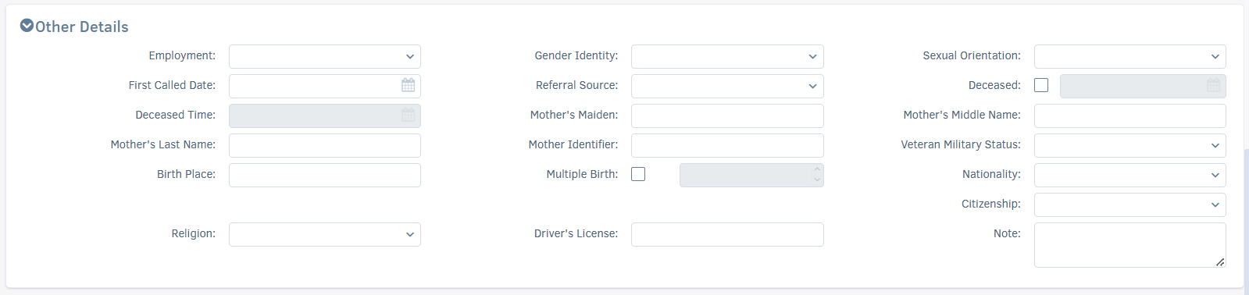

*Figure 4.5 patient other details*

**4.1.6 other pharmacy/allergy details**

In this section users can add patient pharmacy or patient allergy details.

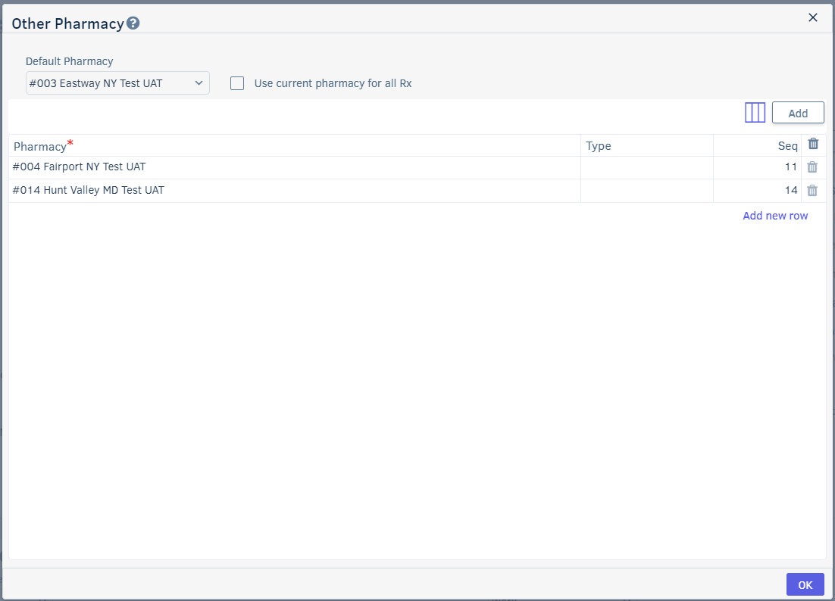

*Figure 4.6 other pharmacy/allergy details*

## Software Interfaces

| Software used | Microsoft Visual Studio Code, postman, Microsoft Visual Studio Code |
| --- | --- |
| Language Used (front end) | Html, Css & scss |
| Framework used (backend) | .NET |
| Database | PostgreSQL |

*Table 1 Software Interface*

## Communications Interfaces

We can access the IMS using web browsers like Mozilla Firefox, Google Chrome, Microsoft Edge, Opera. HTTPS protocols will be used to communicate with the web browser in this project for security purposes.

# Other Nonfunctional Requirements

## Performance Requirements

## Response Time: The system provides one-second consent once 'patient information has been checked after booking.

## Strengths: The program needs to support at least 1000 people at a time.

## User interface: User interface agrees within five seconds. o Backup: The system provides efficient backup of data.

## Errors: The system will track all errors and maintain its own log. If the data does not come correctly the email task you have to do.

## Security Requirements

## Patient Identification: The system requires the patient to see themselves using the phone. Logon Id: Any users who use the system need to hold a Logon ID and password depending on the location.

## Modification: Any modification such as adding, deleting, renewing, etc. on the website can be synchronized quickly and done by the site manager only. o Front Desk Staff Safety Rights: The front desk staff can view any data throughout the Medical Health Record, add a new patient record as they enter, rather than the safety of a particular screen of every patient, so the administrator can assign rights to their clinic staff.

## Administrative rights: The administrator may view and modify any information in the Medical Billing and Electronical Health system for records management.

## Software Quality Attributes

# Availability: The system is available all the time.

# efficiency: This system works with full high performance with optimum use of internal memory of machines.

# Other Requirements

Define basic health insurance terms related to medical bills and claims process. Explain the basic anatomical, physiological and pathological terms used in the field of health care. Apply the concept of protection and privacy in accordance with HIPAA guidelines. Our project is the only humble business to meet the needs of managing their project. Several easy-to-use codes have also been adopted. The purpose of software design is to provide a framework that allows the client to make appropriate estimates made during the initial period of the software project and should be updated regularly as the project progresses. And also, for backup copy of codebase repository and website regularly on different servers.

**Appendix A: Glossary**

**IMS:** Intelligent Medical Software

**FR:** feature

**NPC:** New Patient Creation

**PDR:** Patient Data Retrieval

**PDU:** Patient Data Updating

**PDD:** Patient Data Deleting

**PAS:** Patient Allergy Section

**Appendix B: Analysis Models**

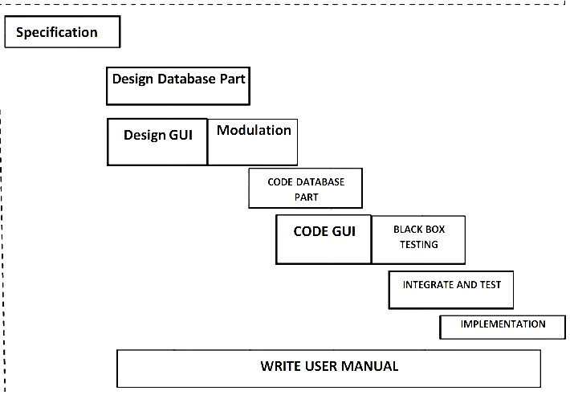

*Fig B.1 Gantt Chart*

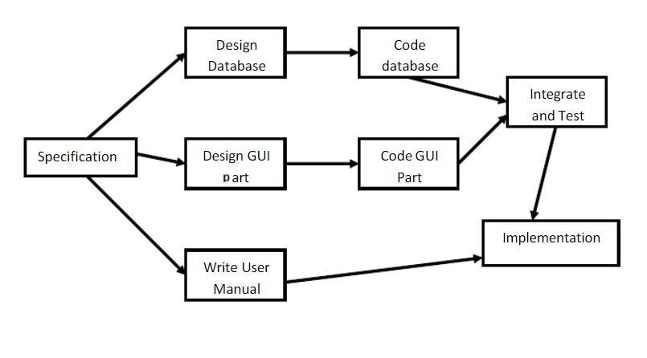

*Fig B.2 Pert Chart*

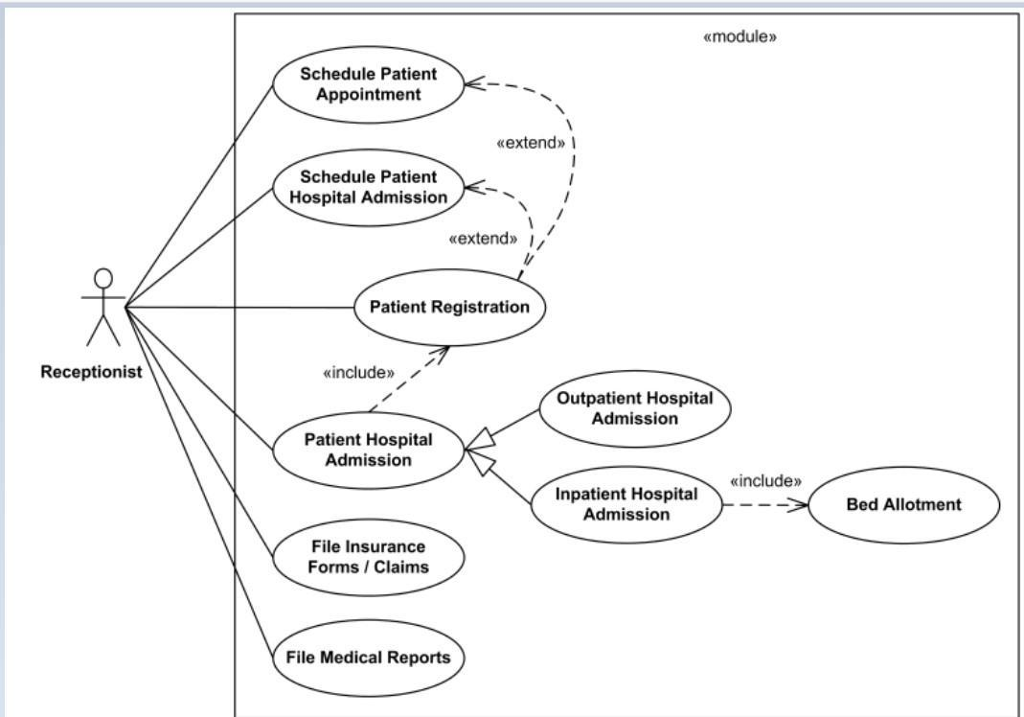

*Fig B.3 Use Case diagram*

**Appendix C: Issues List**

Compliance with healthcare policies, Increasing patient number, Delivery of quality healthcare services, Inefficiencies in different administrative procedures and systems. healthcare professional able to keep themselves safe in the era off pandemic with programmed robots. Integrate multiple load balancers to distribute the loads of the system.